**3.7 X-ray photons** In *chest radiology*, a patient’s chest is exposed to X-rays, and the X-rays passing through the patient are recorded on a photographic film to generate an X-ray image of the chest for medical diagnosis. The average wavelength of X-rays in chest radiology is about 0.2 Å (0.02 nm). Numerous measurements indicate that the patient, on average, is exposed to total radiation energy per unit area of roughly 0.1 µJ cm-2 for one chest X-ray image. Find the photon energy used in chest radiology, and the average number of photons incident on the patient per unit area (per cm2).

**Solution**

Photon energy,

*Eph* = *hc*/*λ* = (6.63 × 10-34 J s)(3.0 × 108 m/s)/(0.02 × 10-9 m)

∴ ***Eph* = 9.945 × 10-15 J** or **62.15 keV**

Photons per unit,

Φ = *Pλ/hc* = (0.1×10-6 J cm-2) (0.02×10-9 m)/(6.63×10-34 J s)(3×108 ms-1)

∴ **Φ = 1 × 107 photons cm-2**

**3.10 Photoelectric effect** A photoelectric experiment indicates that violet light of wavelength 420 nm is the longest wavelength radiation that can cause photoemission of electrons from a particular multialkali photocathode surface.

*a*. What is the work function of the photocathode surface, in eV?

*b*. If a UV radiation of wavelength 300 nm is incident upon the photocathode surface, what will be the maximum kinetic energy of the photoemitted electrons, in eV?

*c*. Given that the UV light of wavelength 300 nm has an intensity of 20 mW/cm2, if the emitted electrons are collected by applying a positive bias to the opposite electrode, what will be the photoelectric current density in mA cm-2 ?

**Solution**

***a.*** We are given *λ*max = 420 nm. The work function is then:

Φ= *hυo* = *hc*/*λ*max = (6.626 × 10-34 J s)(3.0 × 108 m s-1)/(420 × 10-9 m)

∴ **Φ = 4.733 × 10-19 J** or **2.96 eV**

***b.*** Given *λ*= 300 nm, the photon energy is then:

*E*ph = *hυ* = *hc*/*λ* = (6.626 × 10-34 J s)(3.0 × 108 m s-1)/(300 × 10-9 m)

∴ *E*ph = 6.626 × 10-19 J = 4.14 eV

The kinetic energy *KE* of the emitted electron can then be found:

***KE*** = Φ - *E*ph = 4.14 eV - 2.96 eV **= 1.18 eV**

***c.*** The photon flux Γph is the number of photons arriving per unit time per unit area. If *I*light is the light intensity (light energy flowing through unit area per unit time) then,



Suppose that each photon creates a single electron, then

*J* = Charge flowing per unit area per unit time = Charge × Photon Flux

∴  = **48.4 A m-2 = 4.84 mA cm2**

**3.13 Planck’s law and photon energy distribution of radiation**

Planck’s law, stated in Equation 3.9, provides the spectral distribution of the black body radiation intensity in terms of wavelength through *Iλ*, intensity per unit wavelength. Suppose that we wish to find the distribution in terms of frequency *ν* or photon energy *hν*. Frequency *ν* = *c/λ* and the wave- length range *λ* to *λ* + *dλ* corresponds to a frequency range *ν* to *ν* + *dν*. (*dλ* and *dν* have opposite signs since *ν* increases as *λ* decreases.) The intensity *Iλ dλ* in *λ* to *λ* + *dλ* must be the same as the intensity in *ν* to *ν* + *dν*, which we can write as *Iν dν* where *Iν* is the radiation intensity per unit frequency. Thus,



The magnitude sign is needed because *λ* = *c/ν* results in a negative *dλ/dν*, and *Iν* must be positive by definition. We can simply substitute *λ* = *c/ν* for *λ* in *Iλ* and obtain *Iλ* as a function of *ν*, and then find |*dλ*/*dν*| to find * *from the preceding expression.

a. Show that

 3.81

Equation 3.60 is written to highlight that it is a function of the *photon energy hν*, which is in joules in Equation 3.60 but can be converted to eV by dividing by 1*.*6 × 10-19 J eV-1.

*b.* If we integrate *Iν* over all photon energies (numerically on a calculator or a computer from 0 to say 6 eV), we would obtain the total intensity at a temperature *T*. Find the total intensity *IT* emitted at *T* = 2600 K (a typical incandescent light bulb filament temperature) and at 6000 K (roughly representing the sun’s spectrum). Plot *y* = *Iν/IT* versus the photon energy in eV. What are the photon energies for the peaks in the distributions? Calculate the corresponding wavelength for each using *λ* = *c/ν* and then compare these wavelengths with those predicted by Wien’s law, *λ*max*T* ≈2*.*89 × 10-3 m K.

**Solution**

***a.*** 

or 

 

or 

***b.*** By integrating numerically using any math software, the total intensity

*Iν*(2600 K) = 1.07×10-7 J m-2 = 1.07×10-8 W s-1 m-2

and *Iν*(6000 K) = 3.03×10-7 J m-2 = 3.03×10-7 W s-1 m-2



**Figure 3Q10-1:** Plot of *Iν*/*IT* versus photon energy.

At 2600 K:

From the Fig. 3Q10-1, at the peak in intensity, we get

*hν* = 0.63 eV or *hc/λ* = 0.63 eV

or *λ*2600 = (4.135×10-15 eV s)(3×108 ms-1)/(0.63 eV) = **1.97×10-6 m** or **1.97 µm**

At 6000 K:

From the Fig. 3Q10-1, at the peak in intensity, we get

*hν* = 1.46 eV or *hc/λ* = 1.46 eV

or *λ*6000 = (4.135×10-15 eV s)(3×108 ms-1)/(0.63 eV) = **8.5×10-7 m** or **850 nm**

Using Wien’s law,

*λ*max*T* = 2.89×10-3 m K

*λ*max = (2.89×10-3 m K/2600 K) = 1.11×10-6 m or **1.11** **µm** at 2600 K

and *λ*max = (2.89×10-3 m K/6000 K) = 4.8×10-7 m or **480** **nm** at 6000 K

|  |  |  |
| --- | --- | --- |
| Temperature (T) | *λ*max (Planck’s law) | *λ*max (Wien’s law) |
| 2600 | 1.97 µm | 1.11 µm |
| 6000 | 850 nm | 480 nm |

**Table 3Q10-1:** Comparison of wavelengths obtained using Planck’s law and Wien’s law.

**3.17 Electron microscope** Diffraction of light by an object becomes important when the wavelength of light is comparable to the object we wish to see. The resolution of an optical microscope cannot therefore be better than the wavelength of visible light, on the order of 500 nm. An electron microscope uses an electron beam (just like light) to "see" small objects because we can make the wavelength of an electron beam very short by adjusting the accelerating voltage. The transmission electron microscope (TEM) is an equipment that allows examining thin slices (or films) of materials under very large magnifications, for example 100,000× or more. As depicted in Figure 3.52, the image formation is exactly the same as that in the optical microscope except that electromagnetic coils acting as electron lenses are used to bend the electron ray. Electrons emitted by the hot cathode are accelerated by the anode which has typically a large voltage such as 100 kV applied to it with respect to the cathode. After passing through the anode, the electrons are collimated into a parallel beam by the condenser lens to be transmitted through the thin sample. An objective lens focuses the transmitted beam onto an intermediate image which is then projected on to a fluorescent screen by the projector lens. The whole apparatus operates under vacuum to avoid collisions of electrons with air molecules. The samples are typically less than 100 nm thick.

*a.* Do you need the wave properties of the electron to explain the operation of the electron microscope? (Explain your answer and consider whether you need interference and diffraction of waves to explain the optical microscope).

*b.* If the operating voltage of a transmission electron microscope is 100 kV, what is velocity of the electrons and their wavelength? (Neglect relativistic effects.)

*c*. Diffraction effects are negligible when the size of the object *d* is much greater than the wavelength  of the wave. For example, the Bragg diffraction condition has no solutions when 2*d* > **. Resolution is therefore comparable in magnitude to the wavelength . What is the theoretical resolution, in order of magnitude, of the electron microscope operating at 100 kV and 300 kV? What do you think limits the resolution in practice?

|  |  |
| --- | --- |
|  |  |
| **(a)** A schematic diagram of a transmission electron microscope. The angles of the electron trajectories with the optical axis are highly exaggerated; they are typically much less than 1°  **Figure 3.52** Transmission electron microscope | **(b)** A Hitachi Transmission electron microscope (HF3300) with an accelerating voltage of 330 kV, maximum magnification of ×× and capable of resolving 0.13 nm. (Courtesy of Hitachi High-Technologies America Inc. |

**Solution**

***a.*** The operation of an optical microscope can be explained very simply by using **geoteric optics**, that is, representing light in terms of rays, which are then bent by lenses. Geometric optics works well when we can neglect the intereference and diffraction of light waves, that is when the light wavelength (**) is much greater than the object features (say *d*) or ** > *d*. Similarly, we can explain the operation of an electron microscope treating the electron as **a particle moving along a trajectory**, i.e. along a line. The trajectory is bent by electrogmatic lenses just as rays are bent by lesnes. We do not need intereference or diffraction to explain the basic principle of operation and the origin of magnification.

We do however need the wave nature of the electron to explain the **resolution** of the electron microscope. Once the object feature becomes small, waves can be diffracted. Bragg's diffraction law 2*d*sin** =  (for first order) shows that diffraction cannot occur whenever sin** > 1 or whenever /2*d* > 1 or  > 2*d*. Put diffrently, this inequality allows us to estimate the resolution limit of a microscope, whether optical or electron. We cannot resolve objects of size smaller than the wavelength of light in the optical miscroscope or electron in the electron microscope.

The momentum of electrons can be evaluated from the accelerating voltage *V* because the kinetic energy gained by the electrons, (*p2/*2*me),* is equal to *eV.*  This in turns makes it possible to adjust the wavelength of electrons by adjusting the accelerating voltage

***b.*** The voltage 100 kV (105 V) accelerates the electron to a *KE* equal to *eV*. From *KE* = *p*2 */* 2*me = eV*, we have

*p =* =

or *p* = **1.709 × 1022 kg ms1**

The momentum *p* = *me v*electron

  *v*electron *= p / me*

or *v*electron *=*  = **1.876 × 108** **m s1**

This velocity is actually is enormous because

*v*electron /*c* = 0.626

Clearly, we cannot neglect relativistic effects as we have done in calculating *v*electron.

The wavelength  = *h / p*

*=*  = **3.88 × 1012** **m or 3.88 pm**

***c****.* The **100** **kV** case was calculated above in *b* which gave  = 3.88 pm, which is an estimate of the *theoretical* resolution of this electron microscope

The **300 kV** case leads to an electron momentum given by

*p = $\sqrt{2m_{e}eV }$* = $\sqrt{2×9.109×{10}^{-31}×1.602×{10}^{-19}×{3×10}^{5}}$

or *p* = **2.959 × 1022 kg ms1**

The De Broglie wavelength  = *h / p*

 *=*  = **2.24× 1012** **m or 2.24 pm**

We know that the lens aberrations can limit the resolution of an optical microscope before the theoretical limit is reached (*d* ~ ) . Similar problems arise in the electron microscope. It is not possible to design a perfect electromagnetic lens that can perfectly focus the electron trajectories. The bending ability of an electromagnet depends on the magnetic field and hence on the current, which has to be precisely controlled. Further, the focusing ability of an electromagnet will *also* depend on the velocity of the electrons. Not all the electrons have exactly identical velocities with a precise value. Small variations in electron velocities will mean different bending trajectories through the electromagnet lens; this is similar to chromatic dispersion in the optical microscope in which different wavelengths experience different amount of bending. Last, but not least, high resolution electron microscopes have be operated on a vibration-free (vibration-damped) floor. The electron microscope above in the photo operates at 330 kV but has a quoted resolution of 0.13 nm; compare with the calculation above.

**3.21 Finite potential energy well** Figure 3.17b shows the allowed wave functions **(*x*), **(*x*) and **(*x*) for the finite potential well. We know that there is a center of symmetry at *x* = *a*/2. Thus, **(*x*) must reflect this symmetry and are either even or odd functions. Therefore, in region II in Figure 3.17a, we have two types of possible solutions corresponding to cosine and sine functions about the center of symmetry

 or 

where *A* and *B* are constants. Both satisfy the Schrödinger equation in II. Further, in region III, the wavefunction decays with distance and we can write is as **III(*x*) = *C*2exp(*x*) = *C*3exp[**(*x*  *a*)], where *C*3 is a new constant. Use the boundary condition that at *x* = *a* (a) **II(*a*) = **III(*a*) and (b) *d*II/*dx* = *d*III/*dx* to show that *k* and ** are related by

 or 

What would happen if you were to use the boundary conditions at *x* = 0? Since ** and *k* are related to the energy *E*, we can solve the above to find the energy of the electron. To solve  we need to plot **  and  as a function of energy and find the intersection points of the two curves. Similarly, for the case . Using a graphical solution find the energy levels in a finite potential energy well of height 0.4 eV and width 4 nm. What is your conclusion?

**Solution**



**Figure 3.17** (a) A finite potential energy well has zero potential energy (*V* = 0) inside the well (0 ≤ *x* ≤ *a*) but a finite potential energy (*V* = *Vo*) outside the well (*x* < 0 and *x* > *a*). The *PE* function has a center of symmetry at *x* = *a*/2. (c) A finite *PE* well that has a width 2 nm and a barrier height of 0.5 eV. There are only 3 allowed energy levels. The dashed energy lines are the first two levels of the infinite well.

Given two possible solutions

 or 

and **III(*x*) = *C*3exp[**(*x*  *a*)]

and the boundary conditions at *x* = *a* (a), **II(*a*) = **III(*a*) and (b) *d*II /*dx* = *d*III /*dx*

**Part A, *x* = *a***

At *x = a, *II(*a*) = **III(*a*) so that



∴  (1)

At *x = a,* *d*II/*dx* = *d*III/*dx*



∴ (2)

Dividing (2) by (1), we find

 (3)

Similarly, using 

At *x = a, *II(*a*) = **III(*a*) so that



∴ (4)

At *x = a,* *d*II/*dx* = *d*III/*dx*



∴  (5)

Dividing (5) by (4), we find

 (6)

**Part B, *x* = 0**

Now consider *x* = 0 boundary conditions (a), **II(0) = **I(0) and (b) *d*II /*dx* = *d*I /*dx*

Now, remember that **I(*x*) = *C*3exp[**(*x*  *a*)], because now the *exponential decays towards the left* (see Figure 3.17).

At *x =* 0*, *II(0) = **I(0) so that



∴ 

∴  (7)

At *x =* 0*,* *d*II/*dx* = *d*I/*dx*



∴

∴ (8)

Dividing (8) by (7), we find

 (9)

which is the same equation as in (3).

We can repeat this with the sine wavefunction, 

At *x =* 0*, *II(0) = **I(0) so that



∴

∴ (10)

At *x = a,* *d*II/*dx* = *d*I/*dx*



∴ 

∴  (11)

Dividing (11) by (10), we find

 (12)

Equations (12) and (9) are the same as Equations (6) and (3). Conclusion: Both boundary conditions generate the same set of equations for the energy of the electron.

APPLICATION

A finite quantum well has *a* = 4 nm, and *Vo* = 0.4 eV.

Consider first solving ** = *k*tan(*ka*/2) in Equation (3). Both ** and *k* are functions of energy, that is

 and 

To solve ** = *k*tan(*ka*/2), we can plot ** vs. *E* and we can plot *k*tan(*ka*/2) vs. *E* as shown in Figure 3Q21-1. The black curve is *y* = ** vs. *E*. and the blue curve is *k*tan(*ka*/2) vs. *E.*

The other solutions are given by** = *k*cot(*ka*/2). Figure 3Q21-2 also shows *y* = *k*cot(*ka*/2) as the red curves. In total there are 5 solutions as summarized in Table 3Q21-1. We can find the solutions more accurately by expanding the intersection points as shown in Figure 3Q21-3.

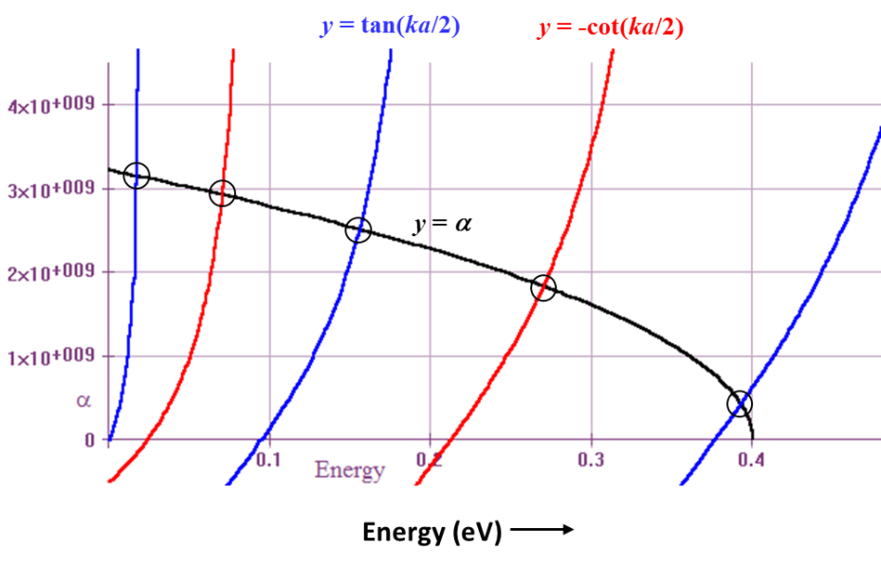

**Figure 3Q21-2:** Solution of ** = *k*tan(*ka*/2) (blue) and ** = *k*cot(*ka*/2) (red) obtained by plotting ** and *k*tan(*ka*/2) as a function of energy *E*; and by plotting ** and *k*cot(*ka*/2) as a function of energy *E*. The intersection points are very roughly, *E*1 ≈ 0.02 eV, *E*2 ≈ 0.07 eV, *E*3 ≈ 0.15 eV *E*4 ≈ 0.27 eV and *E*5 ≈ 0.39 eV represent the solutions to both tan and cot functions.

**Table 3Q21-1** Electron energies in a finite quantum well of width 4 nm and depth 0.4 eV.

|  |  |  |  |  |  |
| --- | --- | --- | --- | --- | --- |
|  | *E*1 (eV) | *E*2 (eV) | *E*3 (eV) | *E*4 (eV) | *E*5 (eV) |
| Finite PE well | 0.0175 | 0.070 | 0.155 | 0.270 | 0.393 |
| Infinite well | 0.024 | 0.094 | 0.212 | 0.376 | 0.588 |

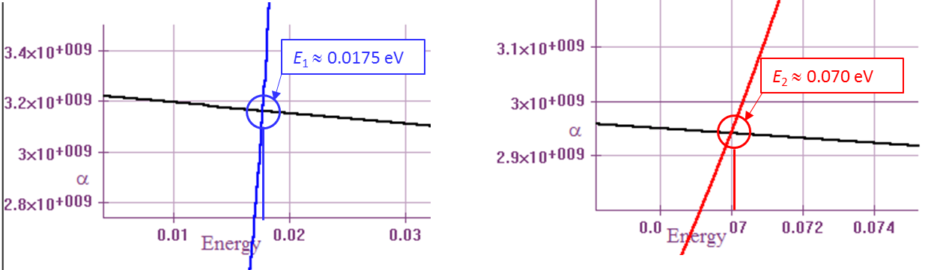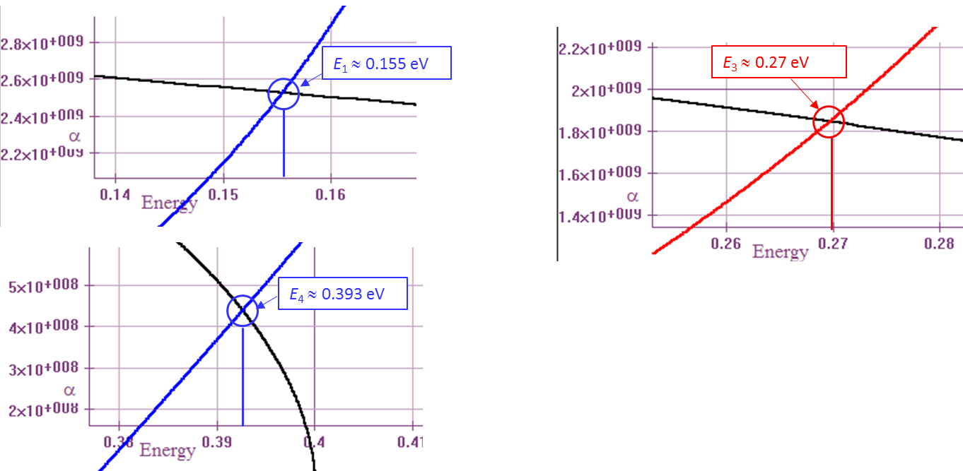

**Figure 3Q21-3:** Solution of ** = *k*tan(*ka*/2) (blue) and ** = *k*cot(*ka*/2) (red) with intersection points in Figure 3Q21-2 expanded.

*Note*: Solving



means that we are looking for a solution, a value of *E*, that satisfies



in which

 and 

We can start by guessing a solution by using a value form an infinite PE well, *E* = *E*1∞, and then, by trial and error (*e.g.* using a Secant or Newton-Raphson Method), finding the solution *E*1. With powerful math software these days, graphical solutions as in Figure 3Q21-3 can be obtained quickly and allow the visualization of all possible solutions.

**3.22 Tunneling**

*a*. Consider the phenomenon of tunneling through a potential energy barrier of height *Vo* and width *a*, as shown in Figure 3.16. What is the probability that the electron will be reflected? Given the transmission coefficient *T*, can you find the reflection coefficient *R*? What happens to *R* as *a* or *Vo* or both become very large?

*b*. For a wide barrier (*αa* >> 1), show that *To* can at most be 4 and that *To* = 4 when *E* = *Vo*.

**Solution**

***a.*** The relative reflection probability or reflection coefficient *R* is given as the ratio of the square of the amplitude of the reflected wave to that of the incident wave, which is:



Also, *R* can be found from the transmission coefficient *T* by the equation *R* = 1 - *T*, as stated in Equation 3.33. From Equation 3.29, *T* is given as:



where *a* is the width of the potential energy barrier, *α* is the rate of decay, and *D* is given by:



To determine the behavior of *R* as *a* or *Vo* or both become very large, we can use the equation *R* = 1-*T* to express *R* in terms of *a* and *D* (remember *D* is a function of *Vo*).



∴ 

We know that sinh() = , and also that 1 /  = 0. Therefore, as *Vo* becomes large, so does *D*, which leads to *T* = 0 and *R* = 1, meaning total reflection occurs. If *a* becomes large then sinh() =  and *T* = 0, making *R* = 1 for total reflection.

***b.*** We need to find the maximum value of *To*. Since *To* depends on the energy *E*, we can differentiate it with respect to *E*, set the result to 0 and isolate *E*.

 (See Equation 3.32)

∴ 

∴ 

Thus *To* is maximum when *E* = *Vo* / 2. If this expression for energy is substituted back into the equation for *To* to find its maximum value (*To*′):



**3.35 Hund’s rule** The carbon atom has the electronic structure 2*s*22*p*2 in its ground state. The ground state and various possible excited states of C are shown in Figure 3.47. The following energies are known for the states *a* to *e* in Figure 3.47, not in any particular order: 0, 7.3 eV, 4.1 eV, 7.9 eV, and 1.2 eV. Using reasonable arguments match these energies to the states *a* to *e*. Use Hund’s rule to establish the ground state with 0 eV. If you have to flip a spin to go from the ground to another configuration, that would cost energy. If you have to move an electron from a lower *s* to *p* or from *p* to a higher *s*, that would cost a lot of energy. Two electrons in the same orbital (obviously with paired electrons) would have Coulombic repulsion energy. 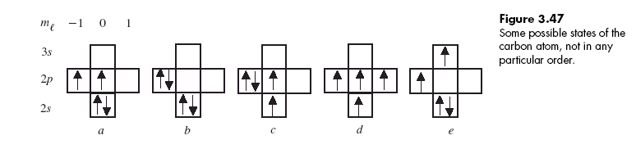

**Solution**

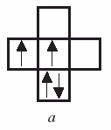

0 eV

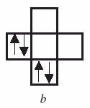

1.2 eV

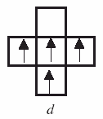

4.1 eV

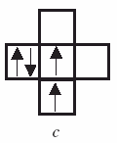

7.3 eV

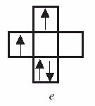

7.9 eV